Title of Paper (Calibri 14pt, bold, Centered alignment):
  - Subtitle title of paper (The same as above)

First Author (Calibri 11pt, Centered)  Department of xxx, University of yyy, Country (8-point)  Xxxx [at] yyyyyy.zz  http://www.yyyyyy.zz/xxx | Second Author  Department of xxx, University of yyy, Country  Xxxx [at] yyyyyy.zz  http://www.yyyyyy.zz/xxxx

This is the place for the abstract of the article. There is no heading Abstract. The text is typed in Calibri 8pt justified, single line spacing, and 6pt Before and After paragraph spacing. If the article is published in the journal, Emille, the abstract will be registered in RILM database.
Keywords: Please put some keywords of your paper here.

Here is the starting place of your body text. Please begin with an introductory paragraph with no primary heading. The body text is set in Calibri 10pt, Justified, and Single line spacing with 6pt Before spacing. Please refer to Figure 1 to arrange each faithfully.
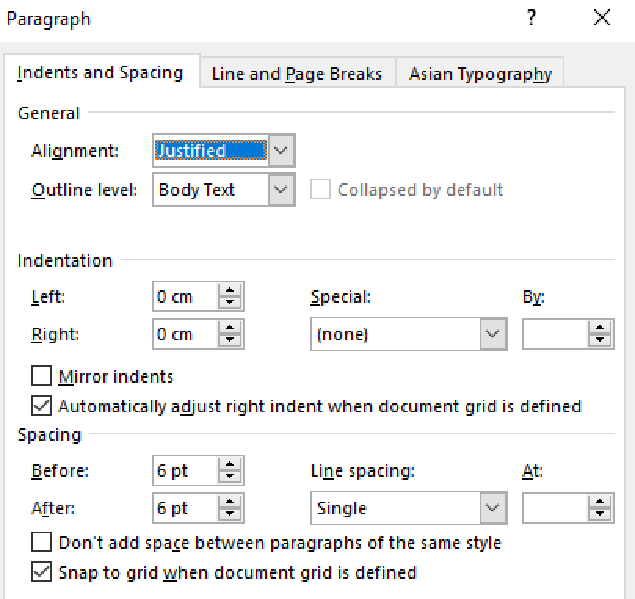
Figure 1. Body text paragraph.
Our documents are based on APA style. If you need any instructions other than we stated here, you can generally follow APA style or feel free to consult with us by email: emille[at]keams.org.

Formatting Summary

Fonts and Styles
All types of font in your paper are Calibri except for the font of headers, Verdana. The bold-style should be used for all kinds of headings. Proper names, terms borrowed from other languages, and any particular words such as technical or unusual terms or phrases to emphasize are to be italicised. Double quotation marks are put for specific persons or groups of people when their identities are essential in your text.

Header and Footer
There is neither header nor footer in the first page. In headers, your name and title should appear from the second page in Verdana 7pt, Left alignment in even pages, and Right alignment in odd pages. The footer shows page numbers and the title of the proceedings with our conference name in Calibri 8pt in the same alignments as headers’. To do so, all three boxes in Design of Header and Footer Tools should be checked for 1. Different First Page, 2. Different Odd & Even Pages, and 3. Show Different Text. The Position of the tools is 2 cm for both Header from Top and Footer from Bottom.
In fact, we already set them in this document, so all you need to do is just to type your name and title once. In case of any problem, you can go through the points above, and check out if its text indicates Single line spacing and if all Indentation and Spacing values are 0.

Page Layout
The size is A4, 21.0 x 29.7 cm(8.3 × 11.7 inches). The margins are Mirrored – Top 2.8 cm - Bottom 3.7 cm- Inside 2.3 cm – Outside 1.7 cm. You can see them in inches below. You can simply choose it from the margins’ dropdown menu, since it has already preset in program.
margins | cm | in. | margins | cm | in.
Top | 2.8 | 1.1 | Bottom | 3.7 | 1.46
Inside | 2.3 | 0.91 | Outside | 1.7 | 0.67
Table 1. Page margins setup.
Two columns are applied to the body below the abstract with 8.25 cm(3.25 in.) Width, 0.5 cm(0.2 in.) Spacing, and checked the box for Equal column width as in Figure 2.
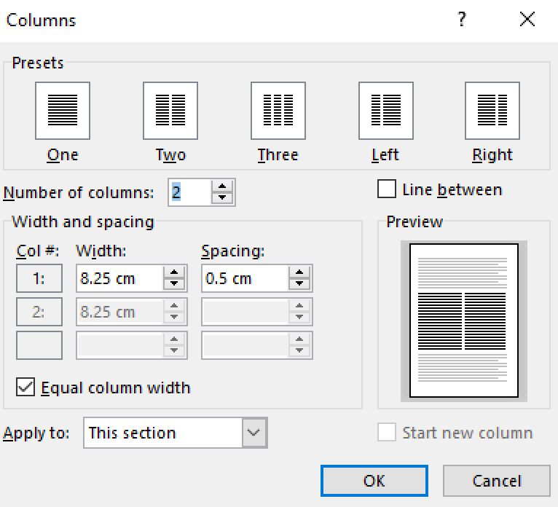
Figure 2. Columns setup.

Primary Headings
Primary headings are Calibri 12pt, bold, and Centered, and 24pt Before spacing like in Figure 3. The primary and the secondary headings are recommended to capitalize the first letter of every word or all major nouns.
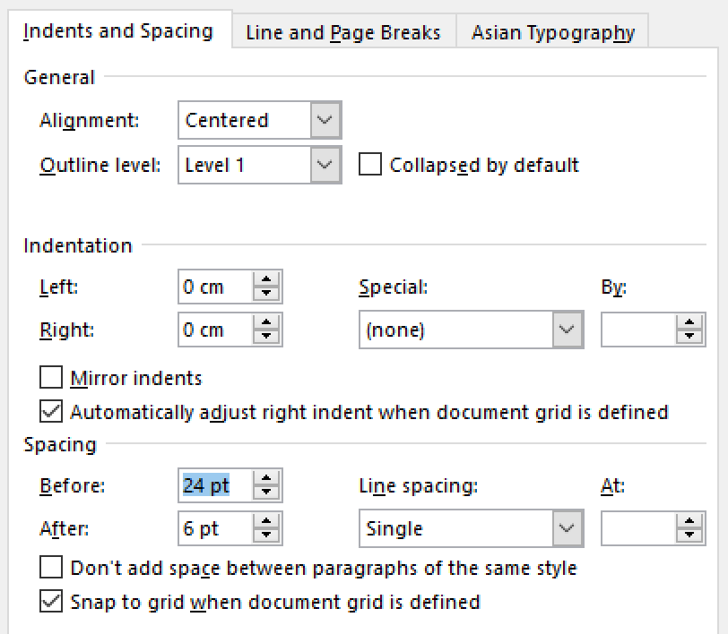
Figure 3. Primary heading paragraph.

Secondary Headings
Secondary headings are set in Calibri 10pt, bold, and Left alignment with 12pt Before spacing.
Tertiary headings, in Calibri 10pt, bold, and Justified, belong to the body. It may or may not end with a period or a comma. You can simply make it bold the first word, phrase or sentence of the paragraph.
Lists can be formed in two ways: numbered or unnumbered.
- This is an example of numbered list.
- Arabic numerals are preferred in this document.
The other way is illustrated below;
- This is an example of unnumbered list.
- This way can be useful when it is not so sequentially stated in context.
Both lists are set in Calibri 9pt, Justified, 0.51 cm Left Indentation, 0.5 cm Hanging, 4pt Before and After spacing, and 0.9 Multiple line spacing, as seen in Figure 4.
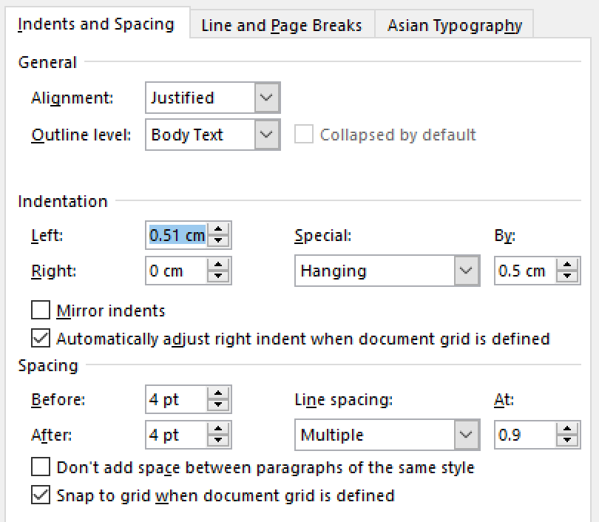
Figure 4. List text paragraph.
Paragraph quotes are set in Calibri 9pt, Justified, 0.51 cm Left Indentation, 5pt Before spacing, and 0.9 Multiple line spacing as in Figure 5.
Just as John Phillip Sousa, . . . believed that recorded music would put an end to live music, so most composers of instrumental music in the mid-20th century refused to accept electronic music. They thought it had no aesthetic value. (Appleton 2016: 80)
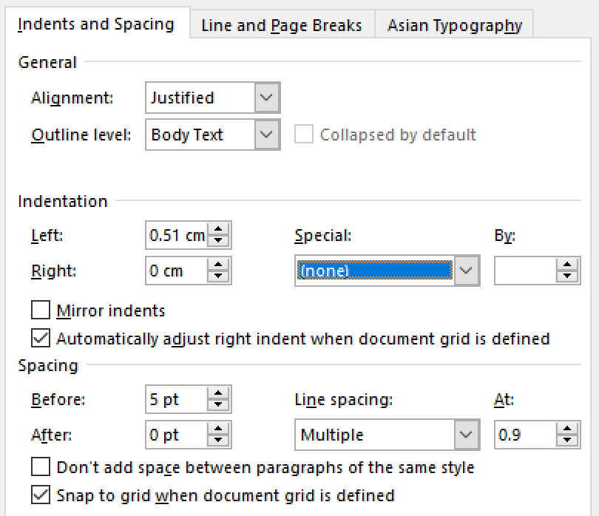
Figure 5. Quoted text paragraph.
The source in parentheses is shown at the end of the paragraph in the order of author’s last name, the published year with no comma between them, and the page number following a colon. As for in-text citation, you can just use normal body-text formats with the source information.
You do need not to put the full reference in the body, but to include it in the reference list in the final section of your document.
Figure and Table is in itself aligned in Centered with 6pt Before spacing. But it is captioned in Calibri 8pt, Left-aligned, 6pt Before and 9pt After spacing. The word Figure or Table, an arabic number, and a period are bold, as seen in Figure 6.
Figure 6. A scene of Jon Appleton, the keynote speaker of KEAMSAC2016 in SBS CulturCulb, TV program.

Content notes
When you want to supplement your comments, we recommend you to use endnotes rather than footnotes. Its Location is set for End of document, Number format should be Arabic numerals, and Apply changes to must be This section, as you see in Figure 7.
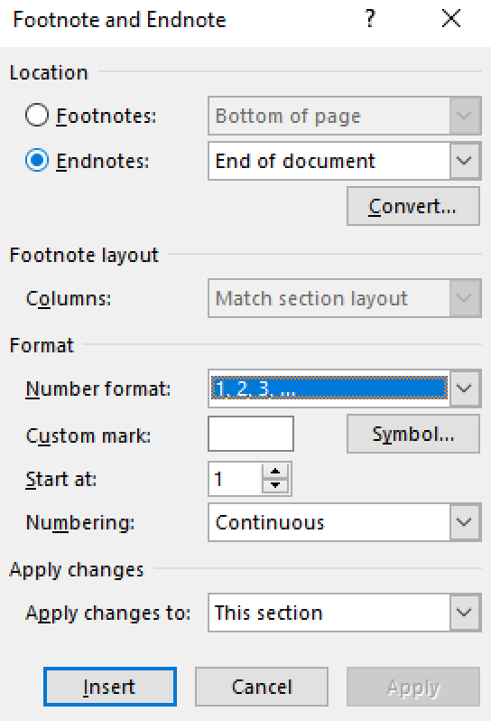
Figure 7. Endnotes setup.
Their texts are Calibri 8pt, Justified, 0.17 cm Hanging Indentation, and 6pt Before spacing like in Figure 8. The superscript numerals are Calibri 10pt.
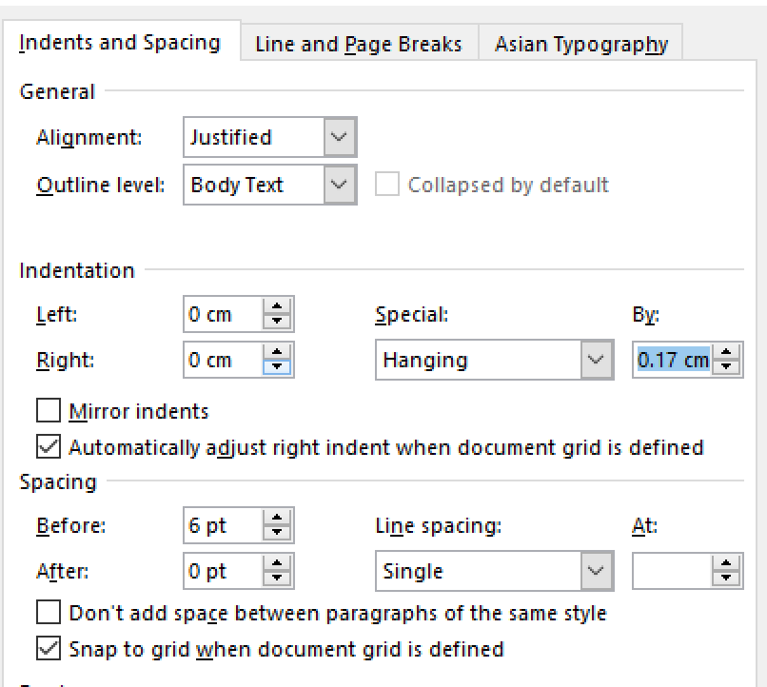
Figure 8. Endnotes paragraph.
If you want only to give source information, please do not use endnotes, put it simply in the body, and give it in full in the reference section.

Referencing List
All referred source must be listed as individual items in the reference section. The word References should be the last primary heading of your paper. Each entry in the section is made in Calibri 9pt, Justified, 1 cm Hanging Indentation, 7pt Before spacing, and 0.9 Multiple line spacing as in Figure 9.
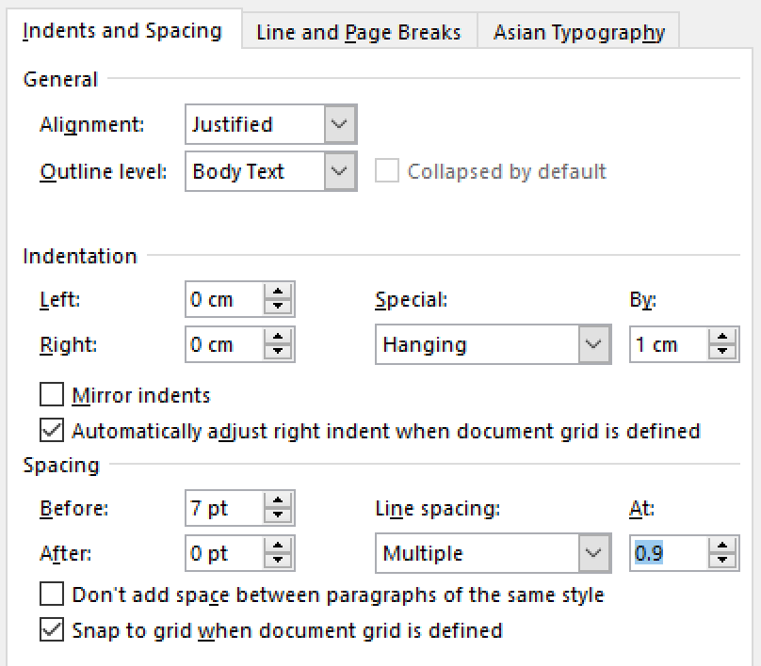
Figure 9. References paragraph.
When you write it, please describe the details as minutely and correctly as possible. Our editors will do double-check every row for sincerity, though. Provide all items with the full name if possible, include the abbreviation after that if you would. The list is alphabetized by the first author’s last name. All authors go last name first, a comma next, and then first and middle names following. Multiple authors are separated with a slash. The year (and date) of publication should be in parentheses. The title of article is not enclosed in quotation marks. Listing a selection from a book or a journal, put “In” before the title of the book or the journal. For a periodical, use a slash between the volume and the issue numbers. We illustrated these respects at the last section of this document.

Submission
Please submit your paper in a .docx file and in a .pdf file. We highly recommend you to use the latest version of Microsoft Word, since we use it in our final editing process. However, if it is not available for you, you can turn it in any other text files. We will convert and/or fix any errors that you might make. For better printing qualities, please use the biggest size of pictures as available, and let us know if some unusual fonts are applied to your document. Most of all, we think that the most important thing is how well your idea expressed in your article. Do not be worried about the format issues too much!
Acknowledgments. If you wish to thank your colleagues or friends, here is the place to do it.

References
Appleton, Jon H. (2016). The Rise of the Anti-Aesthetic in Electro-Acoustic Music. In Proceedings of Korean Electro-Acoustic Music Society’s Conference 2016 (KEAMSAC 2016): 79-84. Seoul: KEAMS.
Author, A. (Year). Title of Book. Location: Publisher.
Author, B. (Year). Title of Work [Web-project]. Location: Organization. http://www.xxx.yyy Retrieved month day, year.
Author, C. (Year). Title of Work. [Please indicate if any special form and others. e.g. Master’s thesis, CD, software, personal recording, unpublished score, unfinished dissertation, etc.]. Location: Related institute.
Author, D. / Author, E. / Author, F. (Year). Title of Article. In Journal Name volume/ issue: pages. Location: Publisher.
Author, G. et al. (Year). Title of article. In Editor’s name, H. [Ed.]. Title of book: pages. Location: Publisher.

Please use [at] instead of @ in your email address. We believe that the way would help you to avoid spam emails.
This is an example of endnotes (Author Year: Page).

